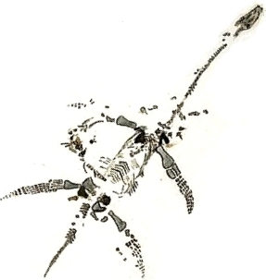 **Jurassic East**

**Saturday 23rd November 2019**

**British Antarctic Survey,**

**Madingley Road,**

**Cambridge**

**CB3 0ET**

|  |  |
| --- | --- |
| **BOOKING FORM** | |
| **Please book me a place.**   |  | | --- | |  | |  |   I enclose a cheque for £35.00 per person payable to Geo-East  ***OR***  Please send me bank account details for electronic payment | |
| **Name(s):** |  |
| **E-mail address:** |  |
| **Postal Address:** |  |
| **Phone number:** |  |
| **Details of any special dietary or accessibility requirements** |  |

|  |  |
| --- | --- |
| **Please post your registration form + fee to:**  Naomi Stevenson  Geo-East  c/o Natural England  Suite D, Unex House  Bourges Boulevard  Peterborough  PE1 1NG | **Or e-mail completed form to**  [**geo_east_treasurer@btinternet.com**](mailto:geo_east_treasurer@btinternet.com)  requesting bank account details |

**Places are limited and cannot be guaranteed until payment is made.   
Please book early to avoid disappointment**